National level workshop
“A-Z Building Construction and surveying, Government jobs and Foreign jobs opportunities”
On 09-03-2020 & 10-03-2020 we Department of Civil Engineering at Adhi College of Engineering and Technology at Radhakrishnan seminar.
Welcome Speech by our Third Year student Ms.Rajashree.
Chief Guest Welcome Addressed by Mr. Sarankumar Assistant Professor
A chief Guest of Mr.kabilan, Executive Engineering, NCC private limited, Assam.
Honor our chief guest by Mrs.P.Vasanthi Head of the Department & Mr.Mahadevan Assistant Professor
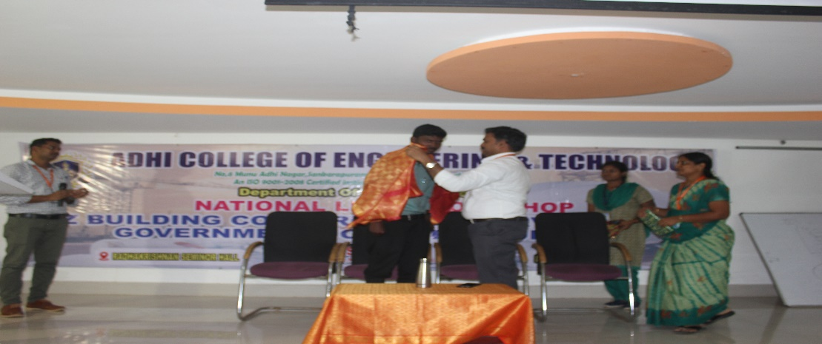
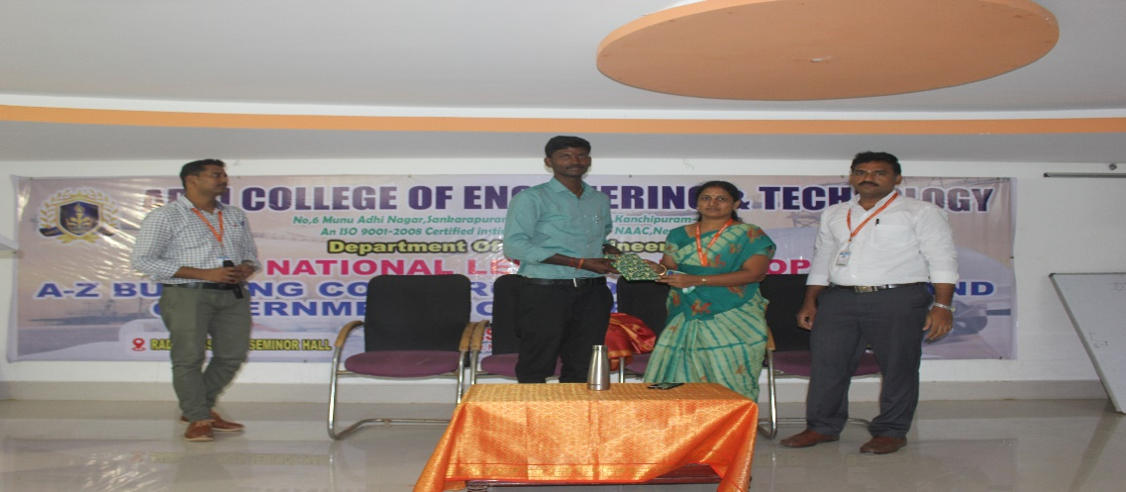
First day he explained about A-Z Building Construction and surveying 09/03/2020
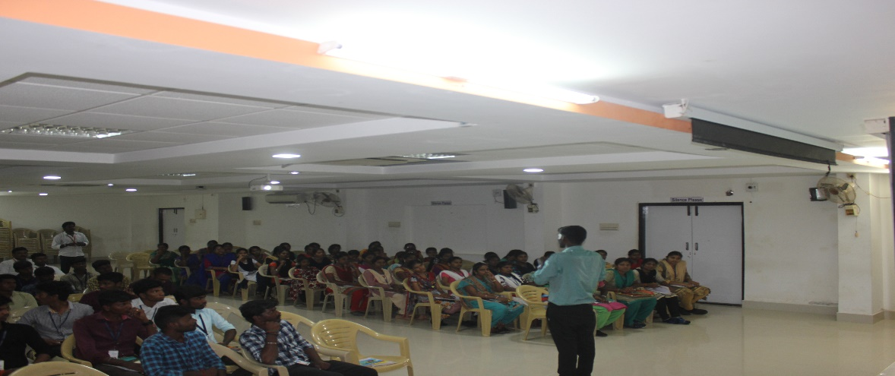
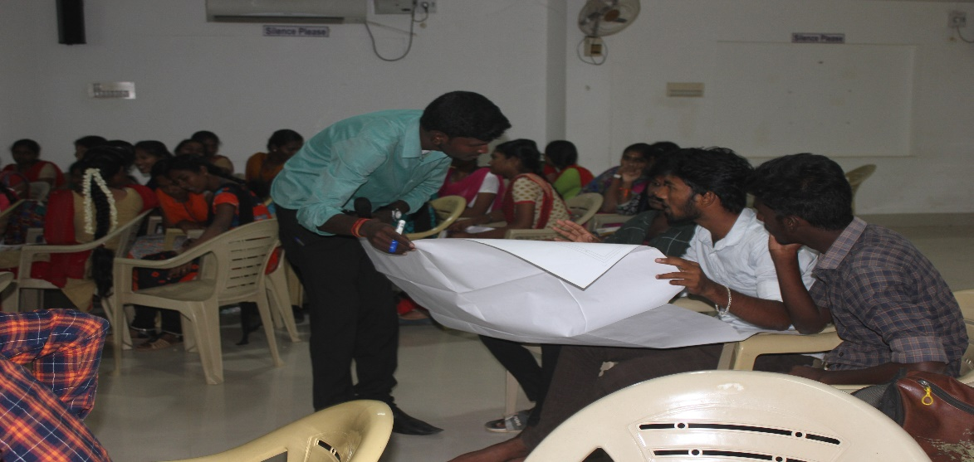
and Second day he had explain about Government jobs and Foreign jobs opportunities 10/03/2020
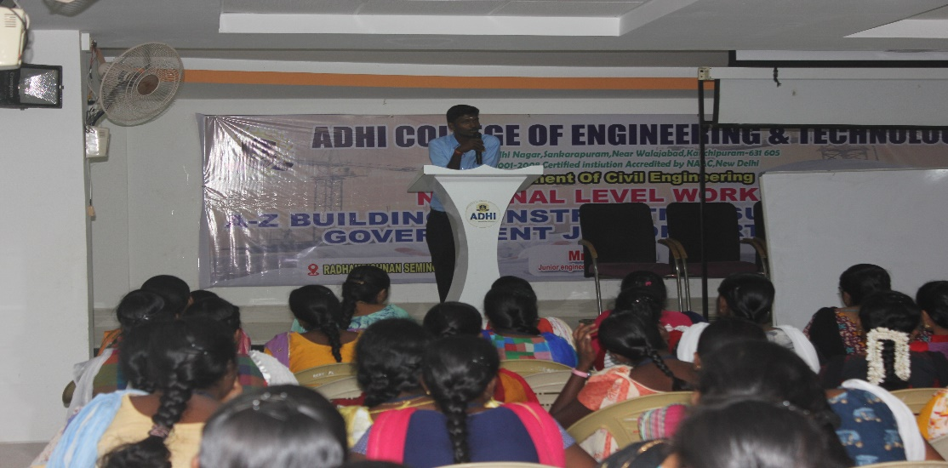
Students Interaction
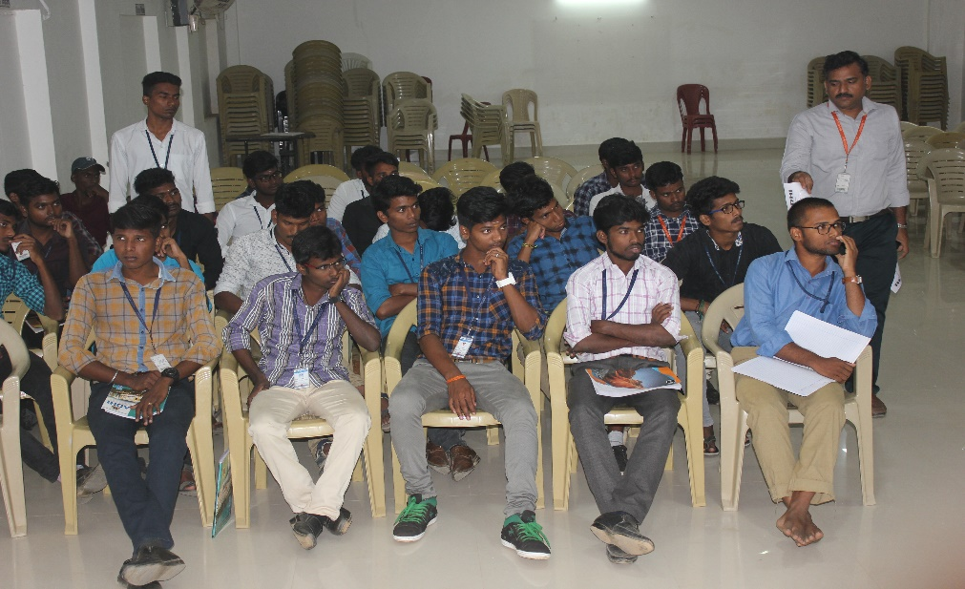
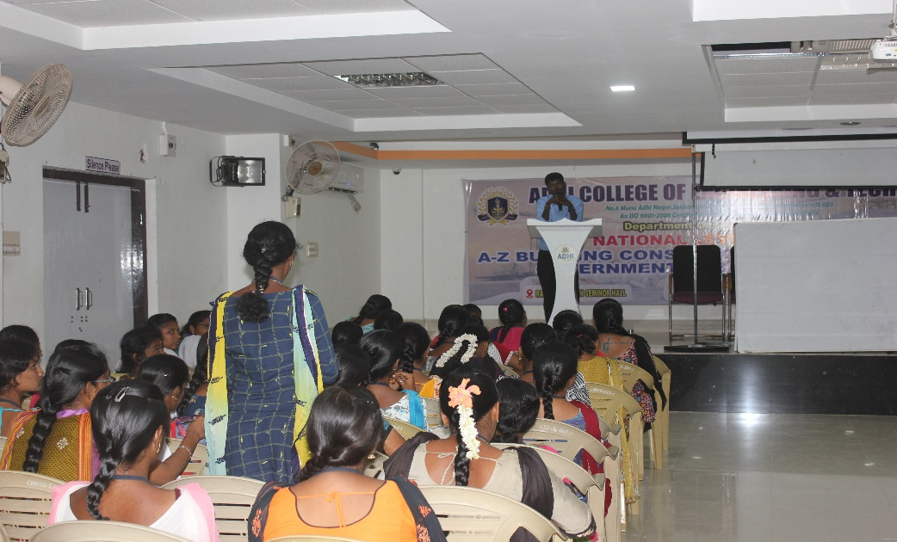
Vote of Thanks contributed through Mr.Prasanth Final year Students

